**Bluetooth Controlled Robot using Arduino**

Apart from Arduino, which is the main controlling module of the project, there are two other important modules that you have to be familiar with in order to implement the Bluetooth Controlled Robot project.

They are the HC-05 Bluetooth Module and the L298N Motor Driver Module.

#### HC-05 Bluetooth Module

The HC-05 Bluetooth Module is responsible for enabling Bluetooth Communication between Arduino and Android Phone.

#### L298N Motor Driver Module

The L298N Motor Driver Module is responsible for providing the necessary drive current to the motors of the robotic car.

**NOTE:** I strongly recommend you to get some idea about Arduino Board, L298N Motor Driver and How to interface motor driver with Arduino Board.

### Circuit Diagram of Bluetooth Controlled Robot

The following is the circuit diagram of Bluetooth Controlled Robot using Arduino, L298N and HC-05.

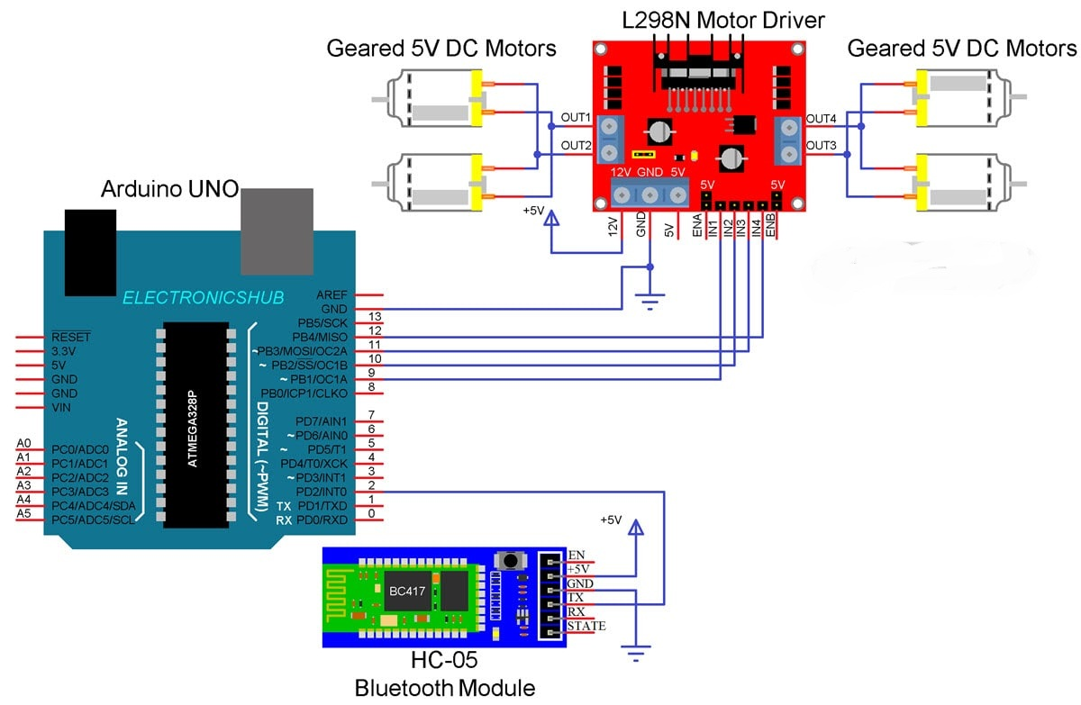

#### Components Required

* Arduino UNO
* L298N Motor Driver Module
* HC-05 Bluetooth Module
* Robot Chassis
* 4 x 5V Geared Motors
* Connecting Wires
* Battery Holder
* Power Supply
* Android Phone
* Bluetooth Controller App

#### Circuit Design

I wouldn’t go into the details of the construction of the robot as your robot chassis might be different from mine and you can easily figure it out how to build the robot from the available parts and possible cable management for making the robot more appealing.

Coming to the design of the circuit, first is the HC-05 Bluetooth Module. The +5V and GND pins of the Bluetooth Module are connected to +5V and GND of Arduino.

Since I will be only transmitting data related to the Robot’s movement from Android Phone to Bluetooth Module and do not intend to receive any data from Arduino, I will connect only the TX pin of the Bluetooth Module to RX Pin of Arduino.

This RX pin of Arduino is based on SoftwareSerial library (Pin 2 and Pin 3 are configured as RX and TX on Arduino). The RX pin of the Bluetooth is left open.

Now, the L298N Motor Driver Module. Digital I/O Pins 9 through 12 of Arduino are configured as Input pins of the Motor Driver and are connected to IN1 through IN4 of the L298N Motor Driver Module. Both the Enable Pins are connected to 5V through provided jumper.

The robot chassis which I am using in this Bluetooth Controlled Robot Car project is supplied with 4 geared motors. Since L298N has slots for only two motors, I have joined the left side motors as one set and the right side motors as other set and connected both these sets to the output of L298N Module.

### Code

The Arduino code for Bluetooth Controlled Robot project is given below.

#include<SoftwareSerial.h>

#define IN1 12

#define IN2 11

#define IN3 10

#define IN4 9

SoftwareSerial mySerial(2, 3); // RX, TX

String data;

int btVal;

void setup()

{

pinMode(IN1, OUTPUT);

pinMode(IN2, OUTPUT);

pinMode(IN3, OUTPUT);

pinMode(IN4, OUTPUT);

digitalWrite(IN1, LOW);

digitalWrite(IN2, LOW);

digitalWrite(IN3, LOW);

digitalWrite(IN4, LOW);

mySerial.begin(9600);

}

void loop()

{

while (mySerial.available())

{

{

data = mySerial.readStringUntil('\n');

//Serial.print(str);

}

btVal = (data.toInt());

switch (btVal)

{

case 1:

//Serial.println("Forward");

forward();

break;

case 2:

//Serial.println("Reverse");

reverse();

break;

case 3:

//Serial.println("Left");

left();

break;

case 4:

//Serial.println("Right");

right();

break;

case 5:

//Serial.println("Stop");

stoprobot();

break;

}

}

if (mySerial.available() < 0)

{

//Serial.println("No Bluetooth Data ");

}

}

void forward()

{

digitalWrite(IN1, HIGH);

digitalWrite(IN2, LOW);

digitalWrite(IN3, HIGH);

digitalWrite(IN4, LOW);

}

void reverse()

{

digitalWrite(IN1, LOW);

digitalWrite(IN2, HIGH);

digitalWrite(IN3, LOW);

digitalWrite(IN4, HIGH);

}

void left()

{

digitalWrite(IN1, LOW);

digitalWrite(IN2, LOW);

digitalWrite(IN3, HIGH);

digitalWrite(IN4, LOW);

}

void right()

{

digitalWrite(IN1, HIGH);

digitalWrite(IN2, LOW);

digitalWrite(IN3, LOW);

digitalWrite(IN4, LOW);

}

void stoprobot()

{

digitalWrite(IN1, LOW);

digitalWrite(IN2, LOW);

digitalWrite(IN3, LOW);

digitalWrite(IN4, LOW);

}

### Android App

Download Bluetooth Controller App from Google Play Store(Free Cost) which is installed on an Android Phone to communicate with the Bluetooth Module.

### Working

Assemble the robot, make the necessary connections and upload the code to Arduino. If you understood the HC-05 Bluetooth Interfacing with Arduino, then understanding the Bluetooth Controlled Robot project is very easy.

First, in the Android App, I have used 5 keys as Forward, Reverse, Left, Right and Stop. The corresponding data associated with each key is as follows:

* Forward – 1
* Reverse – 2
* Left – 3
* Right – 4
* Stop – 5

When a key is pressed, the corresponding data is transmitted to the Bluetooth Module from the Phone over Bluetooth Communication.

In the Arduino code, the Arduino UNO receives any of this data from the Bluetooth Module (as per the key pressed) and performs a simple switch case operation, where each case associated with appropriate instructions to the Motor Driver Input Pins.

### Limitations

* As the range of the Bluetooth Communication is limited (a maximum of 10 meters for class 2 devices for example) the control range of Bluetooth Controlled Robot is also limited.
* Make sure that sufficient power is provided to all the modules especially the Bluetooth Module. If the power is not sufficient, even though the Bluetooth Module powers on, it cannot transmit data or cannot be paired with other Bluetooth devices.

### Applications

* Low range Mobile Surveillance Devices
* Military Applications (no human intervention)
* Assistive devices (like wheelchairs)
* Home automation